Training Guide
Basic Math
Handbook



Preface

The chapters of this book are graduated to different levels of math proficiency. Depending on your level of proficiency you may be able to bypass the first two or three chapters, which review many of the basic math concepts. The following is a brief summary of the different chapters of this book.
The first part of Chapter One reviews the basic math functions such as addition, subtraction, multiplication and division. The concepts of fractions and decimals, ratios and proportions, percentages and analyzing units are reviewed in the latter part of Chapter One.
Chapter Two covers basic geometry, which is essential for calculation, the areas and volumes of water industry treatment and distribution structures. Chapter Three covers the concepts of velocity and flow rates that are commonly used in the water industry. The concepts of pressure, force and head are essential for the operation of water distribution systems and are covered in Chapter Four.
Chapter Five has been dedicated to demonstration examples of water treatment and distribution problems typically encountered by small water systems. These are also the types of example problems encountered on water operator certification exams. Chapter Six is comprised of conversions and formulas commonly used in the water industry. Chapter Seven contains charts and tables commonly referred to in the water industry.

Produced by:
National Rural Water Association
2915 South 13th
Duncan, OK 73533

Basic Math Handbook

Table of Contents

Chapter One Basic Arithmetic ……………………………………………… 5

Chapter Two Basic Geometry ……………………………………………… 18

Chapter Three Velocity and Flow Rates ………………………………… 28

Chapter Four Pressure, Force and Head ……………………………… 34

Chapter Five Typical Water Problems …………………………………. 40

Chapter Six Conversions and Formulas ……………………………… 64

Chapter Seven Charts and Tables ………………………………………….. 74

Basic Math Handbook

Contributing Authors:

Neil Cirard
Louisiana Rural Water Association

James Gammill
Oklahoma Rural Water Association

John Shadwick
Tennessee Association of Utility Districts

Basic Math Handbook

Chapter One

Basic Arithmetic

Addition

Adding 10 plus 10 and reaching a conclusion of 20 is a simple operation, but adding complex numbers like 13,333 and 0.0033 pose a larger challenge. To avoid arriving at incorrect answers when adding complex numbers, follow the basic rules.

- Decimal points and numbers should line up in columns. When this rule is followed correctly, the previous addition problem is easily performed.

13.3330
+00.0033
13.3363

- Be sure you are not adding apples and oranges. All numbers must represent the same type of units, i.e. inches, pounds, feet. For example, in adding the length of two pieces of pipe, if one is 32 inches and the other is 3 ½ feet, you must convert to common units, for example, divide 32 inches by 12 to convert to 266 feet or multiply 3 ½ feet by 12 to convert to 42 inches before adding the numbers.

32 inches OR 2.666 feet OR 2 2/3 feet
+42 inches +3.500 feet +3 ½ feet
74 inches 6.166 feet 6 1/6 feet

- Write down carry over numbers when adding. This will prevent another common error shown by:

(carryover numbers) 11
279 279
+165 which should be +165
334 (incorrect) 444

Basic Math Handbook

Subtraction

Subtraction is the reverse operation of addition and the same general rules apply.

- Keep all decimal points and numbers aligned in columns.

Example: 4.457
-0.050
4.407

2. Carryover numbers are not used in subtraction, but sometimes ‘borrowing’ numbers is required.
2 16 1 (borrowed numbers)

Example: 374
- 286
88

Step One (the ones column) Borrow one unit (10) from the 7 in the tens column. You now subtract 6 from 14 to get 8 in the ones column.

Step Two (column two) You borrowed one unit from the seven, which leaves six. You must now borrow one unit (100) from one hundreds column. You now subtract 8 from 16 to get 8 in the tens column.

After borrowing from the one hundreds column you are left with a 2 in that column. 2 subtract 2 is equal to zero. No entry is needed in the hundreds column.

Checking your answers. The best way to check you answer in a subtraction problem is to use addition. Add your answer to the number you subtracted and you should get the number you subtracted from:

Example: 374 check 88
- 286 +286
88 374
3. Be sure you are subtracting apples from apples and not apples from oranges. You must work in like units.

Basic Math Handbook

Multiplication

Multiplication is a short cut to adding numbers. For example 5 X 4 is simply:
4 + 4 + 4 + 4 + 4 = 20 5x4 = 20

Multiplication can always be checked by addition, but to save time, multiplication tables through 10 X 10 should be memorized.

Multiplication problems involving larger numbers can be solved by addition too, but could take too much time. Simple multiplication steps are preferred.

Example: 12 X 39
1
12 1st Step – Multiply the ones column.
X 39 9 X 2 = 18. Write down the 8 and
8 carry the one to the next column.

1 2nd Step – Multiply the 9 in the ones
12 column by the 1 in the tens column.
X 39 1 X 9 = 9, then add the carry over
108 and write down the answer (10)
next to the ones column.

12 3rd Step – Multiply 3 from the tens
X 39 column by the 2 in the ones column.
108 3 X 2 = 6. Write 6 down in the tens column.
⁶

12 4th Step – Multiply 3 from the tens column
X 39 by 1 in the tens column. 3 X 1 = 3. Write the
108 three down in the hundreds column.
36

108 5th Step – Add numbers. 12 X 39 = 468
+ 36
468

Basic Math Handbook

There are several rules to remember in multiplication.

- The number of decimal places in the answer is equal to the sum of decimal places in
the numbers multiplied.

Example: 12.002 3 decimal places

1.03 + 2 decimal places

36006

00000

12002
12.36206 5 decimal places

- Numbers do not have to be apples and apples. They can be apples and oranges. That is why it is important to specify the units that go with the numbers and include them in the answer.

Example:

A 10-pound weight on the end of a 5-foot lever would produce:
10 lbs. X 5 ft. = 50 ft-lbs

Example:

Four men working three hours each would work:
4 men X 3 hours = 12 man-hours of labor

3. The multiplication operation can be indicated by several different symbols. The most common is the multiplication sign (X) or times sign. Multiplication can also be indicated by parentheses {} or by brackets [] or simply with a dot . The previous example could be indicated several ways, including:

4 men X 3 hours = 12 man-hours
(4men)(3hours) = 12 man-hours
[4men][3hours] = 12 man-hours
4 men. 3hours = 12 man-hours
(4 men). (3 hours) = 12 man-hours

Basic Math Handbook

When solving a problem that uses parentheses or brackets, ALWAYS complete the operations inside the parentheses or brackets before performing other operations
Example: (10-3) (7+2) (3 2)
= (7) (9) (6)
= 7 X 9 X 6
= 378

Example: [12 –(3+2) (3-1)] [8+(6-2]
= [12 – (5)(2)] [8+4]
= [12-10] [12]
= [2] [12]
= 24 Division

Division is a way to determine how many times one number is contained in another. It is a series of subtractions. For example, when we say divide 10 by 2, we are also saying, how many times can we subtract 2 from 10 to reach 0 or a number less than 2.

- By subtraction:
10-2 = 8 (one)
8-2 = 6 (two)
6-2 = 4 (three)
4-2 = 2 (four)
2-2 = 0 (five)

- By division:
5
2 10 How many times does 2 go into 10. The answer is 5. Multiply 5 X 2 to
check your answer.

Division problems can be written many ways, including: 10÷2 = 5

Note: It is always easier to divide by a whole number.

Basic Math Handbook

Fractions

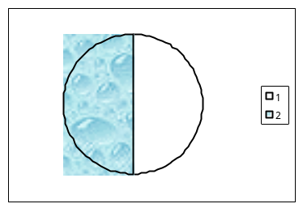 Fractions represent division. The number on the bottom of the fraction represents the total number of equal parts into which an object is divided. This number is called the denominator. The number on top of the fraction, called the numerator, indicates how many of those equal parts are being represented.
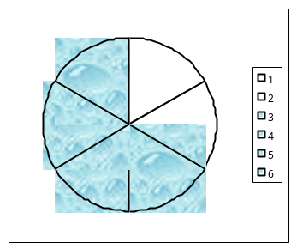
=

Improper Fractions

Improper fractions have a larger numerator than denominator. Therefore, they represent a number larger than one. Improper fractions can be converted to whole numbers or mixed numbers by performing the division operation indicated by a fraction. Divide the numerator by the denominator.

Example:

12 (numerator) 4
8 (denominator) = 12/8 = 8

1
= 2

Basic Math Handbook

Reducing Fractions

To reduce a fraction to its lowest terms divide the numerator and denominator by the largest number that equally divides into both.

Example: 10 = 10÷10 = 1
30 30÷10 3

Note: Dividing or multiplying both the numerator and denominator by the same number does not change the value of the fraction. It is the equivalent of dividing or multiplying by 1 (one).

With complex fractions it may not be easy to determine the largest number that equally divides into both the numerator and denominator. In this case, determine a number (factor) that will divide evenly into both. Continue this process until it can no longer be performed by a number larger than one.

Example:

256 ÷ 2 = 128 ÷ 2 = 64 ÷ 8 = 8
288 2 144 2 72 8 9

Adding and Subtracting Fractions

Before fractions can be added or subtracted the denominators must be the same. If the denominators are the same, simply add or subtract the numerators.

Example: 2 + 3 = 2+3 = 5
8 8 8 8

If the denominators are not the same, they must be manipulated so that they are the same before addition or subtraction can take place.

Basic Math Handbook

To change denominators so that they are equal, fractions must be multiplied by a fraction representing 1 (one), for example 3/3 or 8/8 or x/x, determined by the desired result.

Example:

To add 2/5 and 3/10, fifths must be converted to tenths so that the denominators are the same. Multiply 2/5 by 2/2.

2 + 5 = 2(2) + 5 = 4 + 5 = 9
5 10 5(2) 10 10 10 10

In many cases, one denominator can’t be changed to match another by multiplication. For example, when adding 1/3 and 1/4, the 1/3 can’t be changed to an even fourth. In this case they must both be changed to the Least Common Denominator (LCD). The least common denominator is the lowest number that is evenly divisible by both denominators, 12 in this case. To convert to the LCD each denominator must be multiplied by a fraction representing 1 (one).

Example:

To add 1/3 and 1/4, both must be converted to 12ths.

1 (4) + 1 (3) = 4 + 3 = 7
3 (4) 4 (3) 12 12 12

Multiplying Fractions

To multiply fractions multiply all numerators together to arrive at a new numerator and multiply all denominators together to arrive at a new denominator.

Example:

1 x 3 x 5 = (1)(3)(5) = 15 = 5
4 7 3 (4)(7)(3) 84 28

Basic Math Handbook

Dividing Fractions

To divide two fractions, invert the numerator and denominator of the divisor and multiply.

Example:

1 ÷ 1 = 1 x 2 = 2
3 2 3 1 3

Percentages

Expressing a number in percentage is just another way of writing a fraction or decimal. Think of percentages as parts100. In fraction form the denominator of a percentage is always 100.

To change a fraction to percent, multiply by 100.

Example:

1 x 100 = 100
2 1 2 = 50%

To change a percent to a fraction, multiply by 1/100%

Example:

40% X 1 = 40% = 4 = 2
100% 100% 10 5

Note: the percent signs cancel out.

To change a percentage to a decimal fraction move the decimal point two places to the left.

Example:

28.5% = .285
.01% = .000
100% = 1.00

Basic Math Handbook

Decimals

Decimals are numerical representations of fractions that have 10, 100, 1,000 or some other multiple of 10 as a denominator.

Example:

3 = 0.3 = three tenths
10

13 = 0.13 = thirteen hundredths
100

Changing a fraction to a decimal

To change a fraction to a decimal, divide the numerator by the denominator.

Example:

3 = 3 ÷ 4 = 0.75
4
4 goes into 30 7 times 28

Changing a decimal to a fraction

To change a decimal to a fraction, multiply the decimal by a fraction that represents 1 (one) and has a multiple of 10 in the numerator and denominator, like 10/10, 100/100 etc.

Example:

0.0625 x 10,000 = 625 = 125 = 1
10,000 10,000 2,000 16

Basic Math Handbook

Ratios and Proportions

A ratio is the comparison of two numbers of like units. For example, 1 foot compared to 4 feet (1/4 feet) or 3 pipe length compared to 7 pipe lengths (3/7 pipe lengths).

A proportion is made of two equivalent rations. For example, 4/8 is equal to 1/2.

To solve proportions when one number is unknown, use cross multiplication. Multiply the numerator of one ratio by the denominator of the other ration. This sum should be equal to the number derived by multiplying the denominator of the first ratio by the numerator of the second ratio.

Example:

A C
B D A times D = B times C

When one ratio is known and either the numerator or denominator of a second ratio is known, this cross multiplication technique can be used to find the unknown number.

Example:

X = 1
6 3

(X)(3) = (6)(1)

X = 6
3

X = 2

Proportions come in handy in numerous water calculations. See the following page for an example.

Basic Math Handbook

Example:

If 2 lbs of salt are added to 11 gallons of water to make a solution of a specified strength, how many pounds of salt must be added to 121 gallons to make a solution of the same concentration?

2 lbs = __ X___
11 gal 121 gal

(X)(11 gal) = (2 lbs)(121gal)

X = (2lbs)(121 gal)
11 gal Note: gallons cancel each other out

X = 242 lbs
11

X = 242 lbs ÷ 11

X = 22 lbs

Therefore, 22 lbs of salt must be added to 121 gallons of water to reach the same concentration as when 2 lbs of salt is added to 11 gallons.

Basic Math Handbook

Analyzing Units

By analyzing units (called dimensional analysis) in a formula or mathematical calculation you can determine if the problem is set up correctly. To check a math setup, work only with the units of measure and not with the numbers. To analyze math setups you need to know three things.

- How to convert a horizontal fraction to vertical.

Example:

cu ft/min = cu ft
min

2. How to divide by a fraction.

Example: Gal/min ÷ gal/cu ft = gal x cu ft
min gal

3. How to cancel terms.

Example:

gal x cu ft = cu ft
min gal min

Basic Math Handbook

Chapter Two

Measuring lines, area and volume

LINEAR MEASUREMENT

Linear measurements determine the length or distance along a line or curve, and are generally expressed in English units (inches, feet, yards, and miles) or metric units (centimeters, meters, and kilometers). These measurements of distance are used to determine lengths, perimeters of shapes, diameters of circles, and circumferences of circles.

Perimeters

Perimeters of shapes that are made up of straight lines are determined by adding the length of each side.

For example:

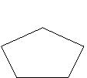

Perimeter=
3+8+2+6+5
= 24 feet
Perimeter =
7+7+7+7
= 28 feet
Perimeter =
1.5+7+7+1.5
= 17 feet

Formula:
Perimeter = length¹ + length² + length³ + length etc…

Perimeter calculations can be used to determine how many linear feet of pipe will be necessary for a specific design or how much wire will be needed to fence off an area.

Basic Math Handbook

Circles

There are three main linear measurements of circles: circumference, diameter, and radius. These measurements are necessary for determining areas of circles and volumes of cylinders and spheres.
Circumference
The diameter of a circle is the length of a
straight line that crosses the center of the circle from
one edge of the circle to another. It is twice the length
of the radius. It can be determined by the formula: D = 2r
where: D = Diameter
R = radius

The radius of a circle is the distance from the center of the circle to the edge of the circle. It can be determined by the formula: D
r = 2

Where: r = radius, and D = Diameter

The circumference of a circle is the distance around the circle and is always equal to 3.1416 times the length of the diameter. The special relationship between the diameter and circumference generates a constant number named pi (pronounced pie) and is designated by the Greek symbol ().
= 3.1416. If you know the diameter of a circle you can always calculate the circumference using the formula:
C = D
Where: C = Circumference
D = Diameter
= 3.1416

CALCULATING AREA

Measuring area determines the size of the surface area of a shape. These measurements are normally referred to in units of square inches, square feet or square yards. Metric units used to indicate area are square millimeters, square centimeters and square meters.

Basic Math Handbook

There are three basic shapes used in water treatment plant calculations: rectangles, triangles, and circles.

Formulas:
Rectangle Area = (length)(width)
= lw

Triangle Area = (base)(height)
2

= bh
2

Circle Area = (0.785)(Diameter²)
= (0.785)(D²)
or
= (3.14)(radius²)
= (3.14)(r²)
= r ²

Rectangles

Area of rectangle A = (length)(width)
= (4 feet)(3feet)
= 12 square feet

Note: Each square is equal to 1 square foot. Check this calculation by counting the squares

Basic Math Handbook

Triangles

The area of a triangle is equal to the base length of the triangle times the height of the triangle divided by two. The height of the triangle must be measured vertically from the horizontal base.

Area of triangle A = (base)(height)
2
= (4 feet)(3 feet)
2
= 12 square feet
2
= 6 square feet

Note: The area of any triangle is equal to ½ the area of the rectangle that can be drawn around it. The area of the rectangle is B x H. The area of the triangle is ½ B x H.

H

B

Basic Math Handbook

Circles

The most familiar formula for the area of a circle is r². The r stands for radius, the distance from the center point of the circle to the edge of the circle. The radius of any circle is equal to half the diameter. The area of a circle can also be derived by using the formula (0.785)(D²).

Area of circle A = r²

= (3.14)(D/2)²

= (3.14) (1²)

= 3.14 square feet

or

= (0.785)(D²)

= (0.785)(4)

= 3.14 square feet

Basic Math Handbook

CALCULATING VOLUMES

Volume measurements represent the amount of space an object occupies. Volume is commonly measured in cubic inches, cubic feet, cubic yards and gallons. Metric units used to measure volume are cubic centimeters, cubic meters and liters.

1 cubic inch

Volume measurements are closely related to area.

Formula: Volume = (Surface Area)(Depth)

The surface area that is used to calculated volume is the area that represents the basic shape of the object. The shaded areas on the objects below represent surface areas. The depth measurement for these objects is indicated.

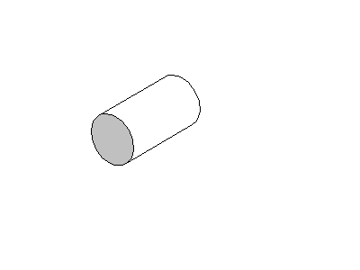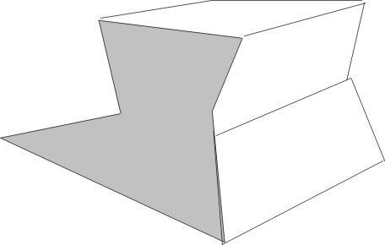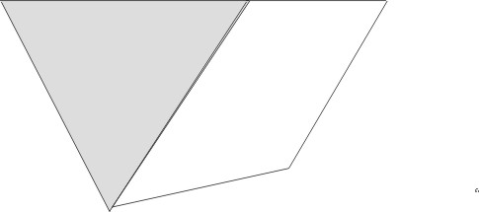

Basic Math Handbook

Formulas:

Rectangular Tanks or Basins
Volume = (area of rectangle)(depth)
= (lw)(depth)

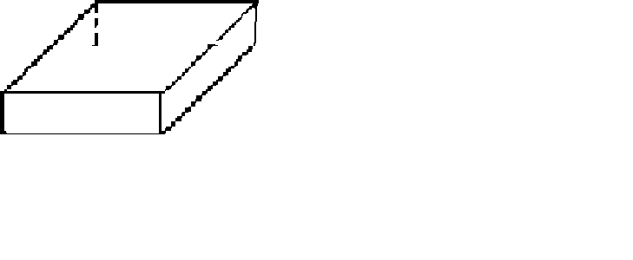
4ft

Rectangle example: = (area of rectangle)(length)
= (4 ft X 6ft)(3 ft )
= 72 cu. Ft.

Troughs

Volume = (area of rectangle) (depth)

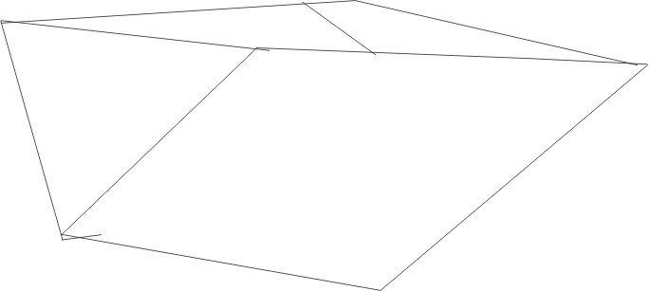

(bh)(length)
2

Trough example: = (area of triangle)(length)
= (2ft X 3 ft)(5 ft)
2
= (3 sq ft)(5 ft)
= 15 cu. ft.

Basic Math Handbook

Cylinders

Volume = (area of circle)(depth)
= (0.785 D²)(depth)

Cylinder example:
Volume = (circle area)(depth)
= (0.785 D²)(depth)
= (0.785)(9 sp ft)(5ft)
= 35.325 cubic feet

Cones
Volume = 1/3(volume of cylinder)
= (0.785 D²)(depth)
3
.
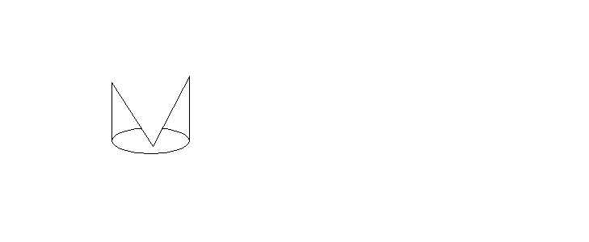

Cone example:
Volume = 1/3(volume of cylinder)
= (0.785 D²)(depth)
3
= (0.785)(4 sq ft)(4 ft)
3
= 4.18666 cubic feet

Basic Math Handbook

Spheres

Volume = ()(Diameter)³
6

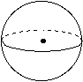

20 feet

Sphere example:
Volume = ()(Diameter)³
6
= (3.14)(20 ft)(20 ft)
6
= 4,186.66 cubic feet

Combination Shapes

Sometimes tanks or other containers consist of multiple shapes and there is no representative surface area for the whole shape. In these cases, the volume can often be calculated by breaking the shape down into easily measured parts, calculating the volume for each part, and then adding the volumes together.

Combination examples:

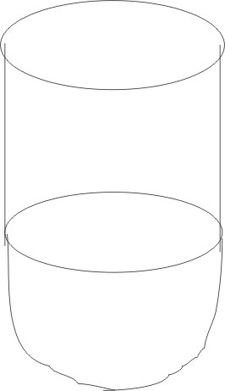
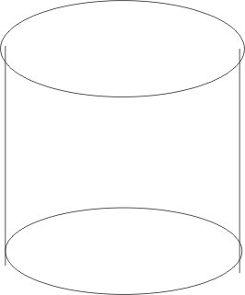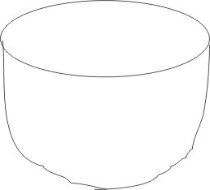
Combination Cylinder Half of Sphere
Tank = Volume + Volume

Basic Math Handbook

Combination examples:

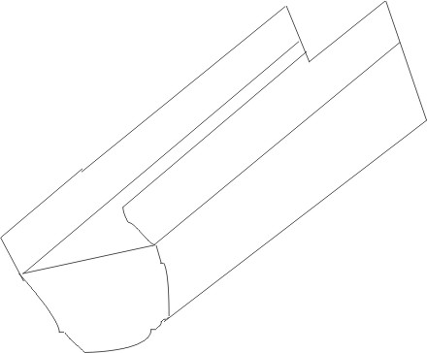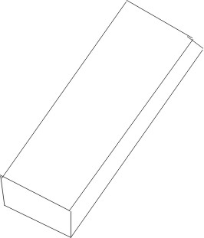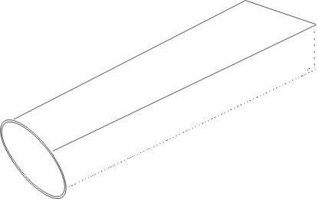
Combination = Rectangle + Half of Cylinder
Trough Volume Volume

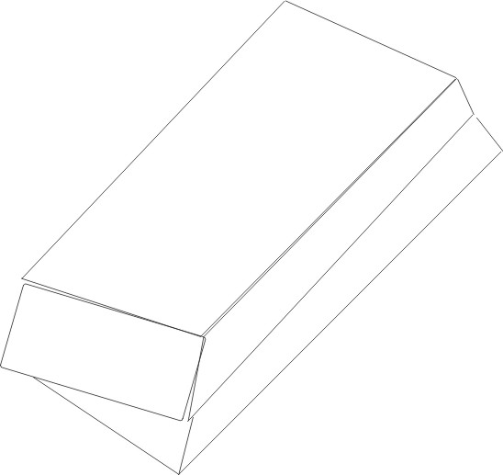

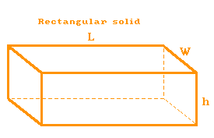
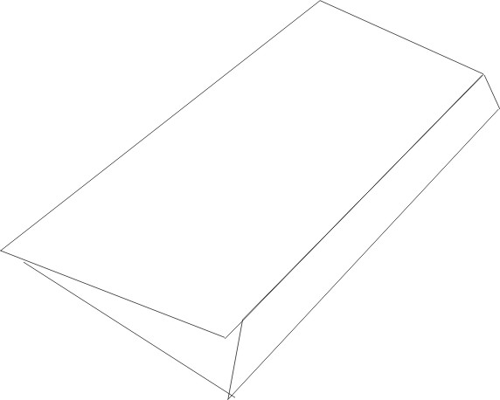
Combination = Rectangle + Triangle Volume
Tank Volume Volume

Combination = Cone + Cylinder Volume

Basic Math Handbook

Chapter Three

Velocity and Flow Rates

Velocity

Velocity is the measurement of the speed at which something is moving. It is expressed by the distance traveled in a specific amount of time. Velocity can be expressed in any unit of distance per any unit of time, as in three miles per year, a mile per second, etc., however, for the purpose of measuring water’s rate of flow in a channel, pipe, or other conduit, it is usually expressed in feet per second, or feet per minute.

Formula: Velocity = Distance (unit)
Time (unit)

Example:

The water in pipe travels 210 feet every three minutes. The velocity of the water would be figured:

210 (ft)
V = 3 (minutes)

V = 70 feet per minute

To convert this answer to feet per second, multiply by 1 min./60 seconds (one minute is equal to 60 seconds, so this fraction is equal to one and does not change the relative value of the answer)

V = 70 feet X 1 minute
1 minute 60 seconds

V = 70 feet
60 seconds

V = 1 1/6 feet per second

Basic Math Handbook

Flow Rates

Measuring the rate of water flow is essential for the efficient operation of treatment plants and distribution systems. Flow rates can be used to determine chemical dosages, water sage of various sources, system efficiency, and future expansion needs.
Two types of flow rates are commonly used, current flow rates, and average flow rates. Durrent flow rates. Current flow rates measure the flow of water as it is happening. Average flow rates are derived from a record of current flow rates to determine the flow rate over a given period of time, like the average flow per day.

Calculating Flow Rates

Flow rates are a function of surface area times velocity. For example, if the velocity in the channel below is 1 ft per second, then every second a body of water 1sq ft in area and 1 ft long will pass a given point. The volume of this body of water would be 1 cubic foot. Since one cubic foot of water passes every second, the flow rate is 1 cubic foot per second, or 1 cfs.

1ft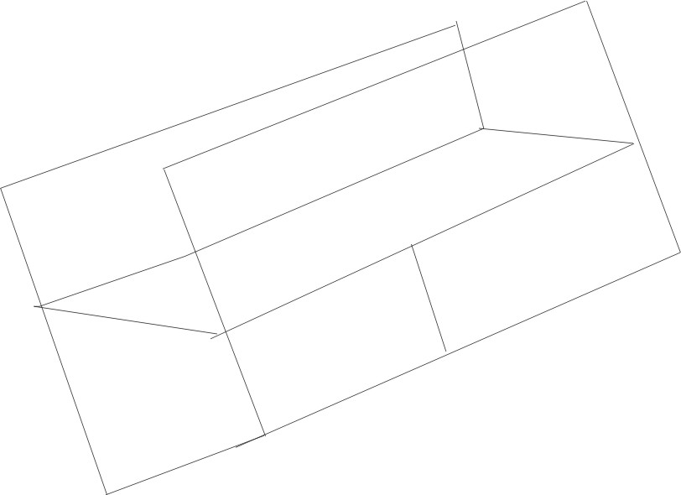
1ft

Formula: Flow Rate = (Area)(Velocity)

Q = AV

Where: Q = Flow Rate
A = Area
V = Velocity

Basic Math Handbook

Flow rate units of measurement are normally dependent on the unit of measurement used for the velocity variable. If the velocity is determined in feet per second, then the flow rate must be expressed as cubic feet per second. If the velocity is represented as meters per day, then the flow rate must be expressed as cubic meters per day.

Calculations:

Circular Pipes (assuming it is flowing full)

Circular Pipe Example

Diameter
= 1 foot

V= 2.5 feet/sec

Flow Rate =(Circle Area)(Velocity)

= (r²)(Distance/Time)

= (3.14)(r²)(2.5 ft./sec.)

= (3.14)(.5ft)²(2.5ft./sec.)

= (3.14)(.25 ft²)(2.5 ft/sec.)

= (.785 ft²)(2.5 ft/sec.)

= 1.9625 cubic feet per second (cfs)

Basic Math Handbook

Rectangular Flow Example:

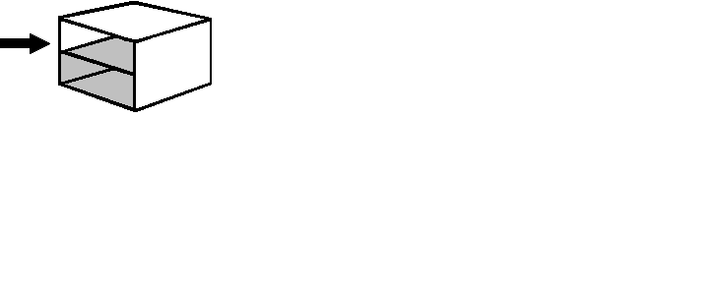

Flow Rate = (Rectangle Area)(Velocity)

= (lw)(1.5 ft./sec.)

= (.5ft)(2ft)(1.ft./sec.)

= 1.5 cubic feet per second (cfs)

Triangle (V-notch) Weir Example:

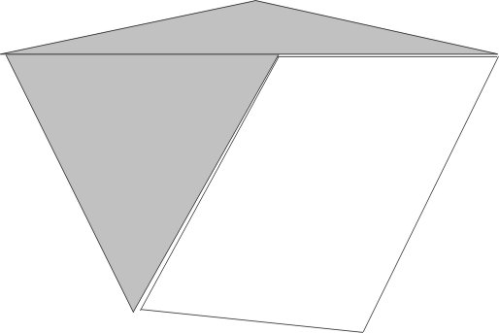

Flow Rate = (Triangle Area)(Velocity)

= (bh)(2 ft./sec.)
2

= (2 ft)(2 ft)(2 ft./sec.)
2

= (2ft²)(2 ft./sec.)

= 4 cubic feet per second (cfs)

Basic Math Handbook

The Continuity Rule

The rule of continuity states that the flow that enters a system must also be the flow that exits the system. The following example illustrates the rule of continuity.

11 cfs = 6 cfs + X cfs
X cfs = 11 cfs – 6 cfs
X cfs = 5 cfs

Flow Rate Unit Conversion

Flow rates can be expressed in a number of different units, including cubic inches per second, cubic feet per second, cubic feet per minute, gallons per minute (GPM), gallons per day (GPD), and millions of gallons per day (MGD). In water flow calculations it is often necessary to convert flow rates to more appropriate units for calculation purposes.

Basic Math Handbook

Example flow conversion problem:

Convert 288 cubic inches per second to million gallons per day (MGD).

- Convert to cubic feet per second

288 cu in/sec X 1______
1,728 cu in/ cu ft. = 0.167 cfs.

- Convert to cubic feet per minute

0.167 cfs X 60 sec/min = 10 ft³/minute

- Convert to gallons per minute (GPM)

10 ft³/minute X 7.48 gal/ft³ = 74.8 GPM

- Convert to gallons per day (GPD)

74.8 GPM X 1440 min/day = 107,712 GPD

- Convert GPD to million gallons per day (MGD)

107,712 GPD = 0.107712 MGD

Note: to convert GPD to MGD, simply move the decimal six places to the left.
To convert MGD to GPD, move the decimal six places to the right.

For additional common conversions and conversion factors, see Chapter 6.

Basic Math Handbook

Chapter Four

Pressure, Force and Head

Force: The push exerted by water on a surface being used to confine it. Force is usually expressed in pounds, tons, grams, or kilograms.

Pressure: Pressure is the force per unit area. It is commonly expressed as pounds per square inch (psi).

Head: Head is the vertical distance from the water surface to a reference point below the surface. It is usually expressed in feet or meters.

Formulas:

Force (lbs.) = psi x area (in square feet)

Head (feet) = psi x 2.31

psi = H x 0.433

OR

Psi = H
2.31

where : H = Head (in feet)
psi = pounds per square inch

1lb
1 lb 12” X 12”

12” X 12”

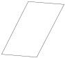

1 lb/sq. in. (psi)
1 lb/sq.ft

Basic Math Handbook

Knowing that a cubic foot of water weighs 62.4 pounds, the force of the water pushing down on the square foot surface area is 62.4 pounds. Using this information, we can determine the pressure in pounds per square inch (psi).

62.4 lb = 62.4 lb
1 sq ft (1 ft)(1 ft)

= 62.416
(12in)(12in)

62.4 lb
= 144 sq in

= 0.433 lb/sq in

= 0.433 psi

0.433 lb
of water
per
square inch

Based on the calculation above, a foot high column of water above one square inch of surface area weighs almost half a pound (0.433 lb), and is expressed as 0.433 psi of pressure. Now that we have determined this factor, it allows us to convert from pressure measured in feet of water to pounds per square inch. The height of water is the most important factor in determining pressures. To convert from psi to feet of head:

1 ft x ft
0.433 psi = 1 psi

x = (1ft)(1 psi)
0.433 psi

x = 2.31 ft

1 psi =
2.31 ft At 1 psi, head = 2.31 feet as shown above.
of Head

Basic Math Handbook

Head

Head is the ratio between foot-pounds of water and pounds, and is measured in feet. For every pound per square inch there is 2.31 feet of head.

Formula: Head (in feet) = psi x 2.31

Head is an important measurement tool in hydraulics. It can be used to determine the hydraulic forces in a pipeline and pump requirements.

There are three types of head:

- Pressure head
- Elevation head
- Velocity head

Pressure head is the measurement of the energy in water from pressure. It is the height above
the pipe that water will rise to in an open ended tube. Pressure head can be used to plot hydraulic gradient lines (HGL).

Elevation head is the measurement of the energy in water from elevation. It is measured from a specific point, like sea level, to a desired point of interest in the system.

Velocity head is the measurement of the energy in water from its flow. The faster the flow, the greater the energy. Velocity head is also determined in feet and is determined by the formula shown below:

Velocity Head = ____V²______
64.4 ft/sec ²

where V = water velocity

Basic Math Handbook

Elevation Head & Pressure Head

An important concept in water systems is the relationship between pressure head and elevation head. The figure below illustrates an open ended tube attached to a tank to measure head. Under static conditions the water level in the tube would rise to the water level in the tank. This water level would represent the elevation head.
This method of measuring head in a system is impractical. Instead of measuring elevation head, water systems install pressure gages in the system to measure pressure head.

Free open
Water end
Surface
Elevation
Head

The illustration above shows head elevation for a body of static water. The head elevation would change if the water was flowing.

Basic Math Handbook

The following illustration demonstrates the relationship between elevation head and pressure head during static water conditions (when the water is not moving). The water level in the water tank and tubes is at the same elevation. Therefore the elevation head is equal to the pressure head throughout the system.
Elevation
Head

Free Water Space

Pressure
Gages
80 80 80

Valve Closed

Basic Math Handbook

Under dynamic conditions (when water is moving in the system) the elevation head and pressure head decrease proportionally as you move away from the tank.

Elevation
Head

Gage
Pressure

72 64 56

Valve open

Basic Math Handbook

Chapter Five

Typical Water Problems

Flow Conversion

GPM to GPD

To convert gallons per minute (GPM) to gallons per day (GPD), multiply by 1440 (the number of minutes in a day).

Example:

20 gpm X 1440 min/day = 28,800 gpd

GPD to MGD

To convert gallons per day to million gallons per day (MGD), move the decimal six places to the left (this is the same as dividing by one million).

Example:

188,000 GPD
1,000,000 = .188 MGD

GPM to MGD

To convert gallons per minutes to million gallons per day, multiply by 1440 (converting to gpd) and divide by one million (or move the decimal six places to the left).

Example:

16 gpm X 1440 min/day = 23,040 gpd

23,040.0 GPD
1,000,000 = 0.023040 MGD

Basic Math Handbook

MGD to GPD

To convert MGD to GPD, multiply by 1,000,000.

Example:

.25 MGD X 1,000,000 = 250,000 GPD

MGD to GPM

To convert MGD to GPM, multiply by 1,000,000 and then divide by 1440.

Example:

.25 MGD X 1,000,000
1440 = 173.6 GPM

or

.25 MGD X 1,000,000 = 250,000 GPD

250,000 GPD X 1 day/1440 min. = 173.6 GPM

Basic Math Handbook

Chemical Dosing

Formula: Chemical Feed in pounds per day (lbs/day)

Chemical Feed = (Flow, MGD)(Dose, mg/L)(8.34 lbs/gal) in lbs/day

An easy way to visualize and use this formula is in a Davidson Pie Chart seen below:

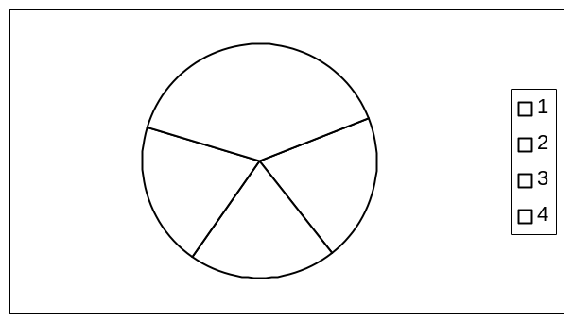

Chemical Feed

To find the Chemical Feed, lbs/day, cover the Chemical Feed portion of the pie as seen below. What is left uncovered represents the correct formula.

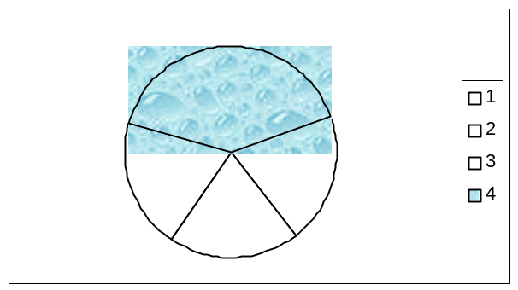
Chemical Feed in pounds per day is equal to:

(Flow, MGD)(Dose, mg/L)(8.34 lbs/gal)

Basic Math Handbook

Sample Problem:

Determine the chlorinator setting in pounds per day if you have a flow of 200 GPM and your target chlorine dose is 2.0 mg/L.

- Convert flow from gallons per minute to million gallons per day (MGD).

Multiply flow in gallons/minute by 1440 (the number of minutes in a day) to convert to gallons per day (GPD).

200 gpm X 1440 min/day = 288,000.0 gal/day

Move the decimal point six places to the left to convert to million gallons per day.

.288 MGD

- Use the formula for chemical feeds to determine the chlorinator setting in pounds per day.

Chemical Feed = (Flow, MGD)(Dose, mg/L)(8.34 lbs/gal)

Chemical Feed = (.288 MGD)(2.0 mg/L)(8.34 lbs/gal)

Chemical Feed = (.288)(2.0)(8.34)

Chemical Feed = 4.8 lbs/day

Basic Math Handbook

Calculating Dose

If you know what the chemical feed and flow are and want to calculate the dose, cover the dose section of the pie to set up the correct formula as seen below.

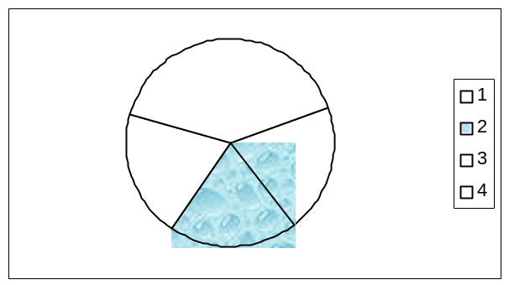
Sample Problem:

A .52 MGD system is feeding chlorine at a rate of 12 lbs/day. What will be the resulting chlorine dose?

Dose, mg/L = Chemical Feed lbs/day
(Flow, MGD)(8.34 lbs/gal)

= 12 lbs/day_______
(.52 MGD)(8.34 lbs/gal)

Dose, mg/L = 2.76 mg/L

Basic Math Handbook

Calculating Flow

If you know what the chemical feed and dose are and want to calculate the flow, cover the flow section of the pie to set up the correct formula as seen below

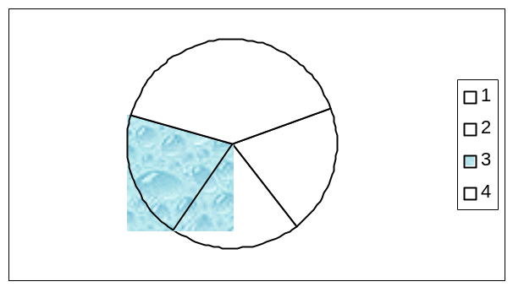

Flow, MGD = Chemical Feed, lbs/day
(Dose, mg/L)(8.34 lbs/gal)

Basic Math Handbook

Detention Time

Formula :

Detention Time, Hr = (Tank Volume, gal)(24 hr/day)
Flow, gal/day

An easy way to visualize and use this formula is in a Davidson Pie chart seen below.

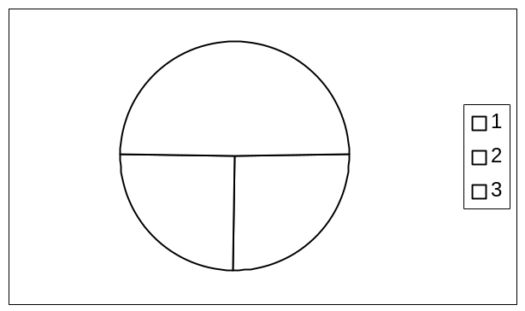

Calculating Detention Time

To determine detention time in hours when the flow and tank volume are known, cover the Detention Time, hr portion of the pie as seen below. What is left uncovered is the correct formula.

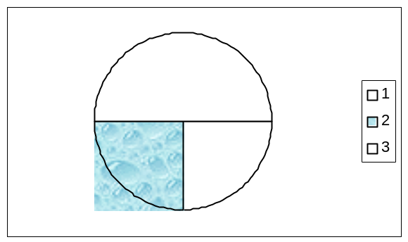
Detention Time in Hours is equal to:

(Tank Volume, gal)(24 hr/day)
Flow, gal/day

Basic Math Handbook

Sample Problem:

A rectangular basin 12 feet long and 9 feet wide is 6 feet deep. It treats a flow of 90,000 gallons per day. Determine the detention time in hours.

Formula:

Detention Time, Hr = (Tank Volume, gal)(24 hr/day)

Flow, gal/day

- Determine tank volume in gallons.

Volume = (length)(width)(depth)
Volume = (12 ft)(9 ft)(6 ft)
Volume = 648 ft³ or 648 cubic feet

- To convert from cubic feet to gallons multiply by 7.48. There are 7.48 gallons in each cubic foot.

648 cu ft X 7.48 gal/cu ft = 4,847 gallons (volume)

- Calculate the resulting detention time in hours using the formula state above.

Detention Time, hr = (4,847 gal)(24 hr/day)
90,000 gal/day

Detention Time, hr = (4,847 gal)(24 hr/day)
90,000 gal/day

Detention Time, hr = (4,847)(24 hr)
90,000

Detention Time, hr = 1.29 hours

Basic Math Handbook

Calculating Flow

If you know what the tank volume and detention times are and want to calculate the flow, cover the flow section of the pie to set up the correct formula as seen below.

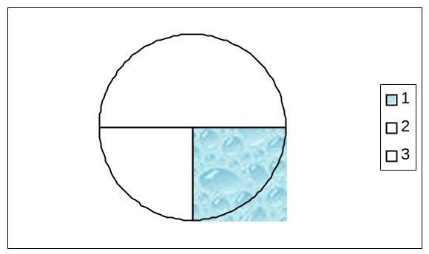
Flow, gal/day = (Tank Volume, gal)(24 hr/day)
Detention Time, hr

Sample Problem:

Determine the required flow in gal/day for a settling basin that is 20 feet long, 10 feet wide, and six feet deep with a detention time of 3 hours.

- Determine tank volume in gallons.

Volume = (l)(w)(d)
= (10)(20)(6)
= 1,200 cu ft

- To convert from cu ft to gallons multiply by 7.48.

1,200 cu ft X 7.48 gal/ft³ = 8,976 gal

- Calculate required flow in gal/day using the formula stated above.

Flow, gal/day = (8,976 gal)(24 hr/day)
3 hr

Flow, gal/day = 71,808 gal/day

Basic Math Handbook

Calculating Tank Volume

This same technique could be used to determine tank volume if you knew the detention time and flow. Cover the portion of the pie that is unknown to set up the correct formulas as seen below.

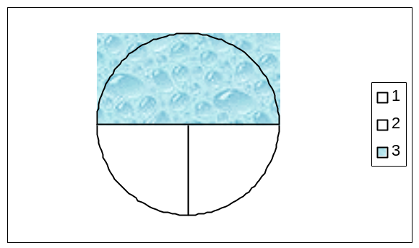

(Tank Volume, gal)(24 hr/day) = (Detention Time, hr)(Flow, gal/day)

Tank Volume, gal = (Detention Time, hr)(Flow, gal/day)
24 hr/day

Basic Math Handbook

Well Disinfection

If the targeted sodium hypochlorite dose to disinfect a well is 100 mg/L, the casing diameter is 15 inches, the length of water filled casing is 40 feet, and sodium hypochlority is 5.25 percent or 52,500 mg/L chlorine, how much chlorine (in gallons) is required to disinfect the well?

Formula:

Chlorine, gal = (Casing Volume, gal)(Dose, mg/L)
Chlorine Solution, mg/L

- Determine the casing volume in gallons using the formula for cylinder volume.

Cylinder Volume = (0.785)(D²)(L, ft)

Casing Volume = (0.785)(1.25 ft)²(40 ft)

Casing Volume = 49.06 ft³ or 49.06 cubic feet

- To convert from cubic feet to gallons multiply by 7.48.
There are 7.48 gallons in each cubic foot.

49.06 cu ft X 7.48 gal/cu ft = 366.99 gallons

- Calculate the required chlorine in gallons using the formula stated above.

Chlorine, gal = (366.99 gal)(100 mg/L)
52,500 mg/L

Chlorine, gal = (366.99 gal)(100 mg/L)
52,500 mg/L

Chlorine, gal = 36,699 gal
52,500

Chlorine requirement = 0.699 gallons

Note: Sometimes concentrations are listed as parts per million (ppm). One ppm is the equivalent of one milligram per liter (mg/L).

Basic Math Handbook

Disinfecting Pipe Sections

To disinfect an 8-inch diameter water main 400 feet long, an initial chlorine dose of 400 mg/L is expected to maintain a chlorine residual of over 300 mg/L during a three hour disinfection period. How many gallons of 5.25 percent sodium hypochlorite solution is needed?

- Determine the volume of water in the pipe in gallons using the volume formula for a cylinder.

Cylinder Volume = (0.785)(D²)(length)

Pipe Volume = (0.785(.667ft)²(length)

Pipe Volume = 139.7 cubic feet

- To convert from cubic feet to gallons multiply by 7.48.
There are 7.48 gallons in each cubic foot.

139.7 cubic feet X 7.48 gallons gal/cu ft = 1,045 gallons

- Determine pounds of chlorine needed.

Formula:

Chlorine, lbs = (Volume, M Gal)(Dose, mg/L)(8.34 lbs/gal)

Chlorine, lbs = (0.001045 M Gal)(400 mg/L)(8.34 lbs/gal)

Chlorine, lbs = 3.49 lbs

- Calculate gallons of 5.25% hypochlorite solution needed using formula below.

Formula:

Hypochlorite, gal = (Chlorine, lbs)(100%)
(8.34 lbs/gal)(Hypochlorite, %)

Hypochlorite, gal = (3.49 lbs)(100 %)
(8.34 lbs/gal)(5.25%)

Hypochlorite required = 7.97 gallons

Basic Math Handbook

Disinfecting Storage Tanks

A storage tank 25 feet in diameter and 10 feet deep is taken off line for maintenance. To disinfect it before use, an initial does of 100 mg/L is expected to create a chlorine residual of more than 50 mg/L for a 24-hour period. How many gallons of 12 percent sodium hypochlorite solution are needed for disinfection?

- Determine the volume of water in the tank in gallons using the volume formula for a cylinder.

Cylinder Volume = (0.785)(D²)(depth)

Tank Volume = (0.785)(D²)(depth)

Tank Volume = 4.906.25 cubic feet

- To convert from cubic feet to gallons multiply by 7.48. There are 7.48 gallons in each cubic foot.

4,906.25 cubic feet X 7.48 = 36,698.75 gallons

- Determine pounds of chlorine needed.

Formula:

Chlorine, lbs = (Volume, M Gal)(Dose, mg/L)(8.34 lbs/gal)

Chlorine, lbs = (.03669875 M Gal)(100 mg/L)(8.34 lbs/gal)

Chlorine, lbs = 30.6 lbs

- Calculate gallons of 12% hypochlorite solution needed.

Formula:

Hypochlorite, gal = (Chlorine, lbs)(100%)
(8.34 lbs/gal)(Hypochlorite, %)

Hypochlorite, gal = (30.6 lbs)(100 %)
(8.34 lbs/gal)(12 %)

Hypochlorite required = 30.58 gallons

Basic Math Handbook

Chlorine Demand

What is the chlorine demand in milligrams per liter if the chlorine dose is 3.2 mg/L and the residual is 0.3 mg/L?

Formula:

Chlorine Demand, mg/L = Dose, mg/L –Residual, mg/L

- Calculate demand.

Chlorine Demand, mg/L = 3.2 mg/L—0.3 mg/L

Chlorine Demand, mg/L = 2.9 mg/L

The chlorine dosage is equal to the chlorine demand plus the residual.

Formula:

Dose, mg/L = Chlorine demand, mg/L + Residual mg/L

The chlorine residual is equal to the chlorine dosage minus the chlorine demand.

Formula:

Residual mg/L = Dose, mg/L = Chlorine demand, mg/L

Basic Math Handbook

Filtration Rates

If a sand filter is 18 feet wide by 24 feet long and treats a flow of 750 gallons per minute, what is the filtration rate in gallons per minute per square foot of filter area?

Formula:

Filtration Rate, GPM/sq ft = ___Flow, GPM__
Surface Area, sq ft

- Determine the surface area of the filter using the formula for the area of a rectangle.

Rectangle Area = (length)(width)

Filter area = (18 ft)(24 ft) = 432 ft2 or 432 sq ft

- Calculate the filtration rate in gallons per minute per square foot.

Filtration Rate, GPM/sq ft = 750 GPM
432 sq ft

Filtration Rate = 1.74 GPM/ sq ft

BACKWASH FLOW

Calculate the backwash flow required in gallons per minute to backwash the filter above at 15 gallons per minute per square foot.

Formula:

Backwash Rate, GPM/sq ft = Backwash Flow, GPM
Surface Area, sq ft

15 GPM/sq ft = Backwash Flow, GPM
432 sq ft

Backwash Flow, GPM = (15 GPM/sq ft)(432 sq ft)

Backwash Flow required = 6,480 GPM

Basic Math Handbook

Weir Loading

What is the weir loading in gallons per minute if the weir is on the outside edge of a 12-foot diameter, circular clarifier that treats a flow of 0.08 MGD?

Formula:

Weir Loading, GPM/ft = Flow, GPM
Weir Length, ft

- Determine the length of the weir using the formula for the circumference of a circle.

Circumference = D

Circumference = (3.1416)(12 ft)

Circumference = 37.7 ft

- Convert flow from million gallons per day to gallons per minute.

To convert from million gallons per day to gallons per day, multiply by 1,000,000 (move the decimal to the right six places).

0.08 MGD X 1,000,000 = 80,000 gallons per day

To convert from gallons per day to gallons per minute, divide by 1440 (the minutes in a day).

80,000 GPD ÷ 1440 min/day = 55.56 GPM

- Calculate weir loading in gallons per minute per foot.

Weir Loading, GPM/ft = Flow, GPM
Weir Length, ft

Weir Loading, GPM/ft = 55.56 GPM
  - ft

Weir Loading = 1.47 gallons per minute per foot

Basic Math Handbook

Pressure

The top of a water tower is 60 feet above ground level. You want to fill the tower to a level 55 feet above ground. What pressure will a gage at ground level read when the water level in the tower is at 55 feet?

Formla:

psi = H X 0.433

or

psi = H_
2.31

p(psi) = 55 X 0.433

p = 23.8 psi

or

p(psi) = 55_
2.31

p = 23.8 psi

The gage at the base of the tower will indicate 23.8 psi when the water level in the tower is 55 above ground level.

Basic Math Handbook

Sample Problem:

The level of water in a 70 foot water standpipe is unknown. However, a pressure gage located at the base of the standpipe indicates 27.3 psi. Determine the level of the water in the standpipe.

Formula:

Psi = H X 0.433

Or

Psi = H_
2.31

27.3 psi = H X 0.433

H = 27.3 psi
0.433

H = 63.1 ft

Or

27.3 psi = H
2.31

H = (27.3 psi)(2.31)

H = 63.1 ft

The water level in the standpipe is located 63.1 feet above ground level.

Basic Math Handbook

Horsepower and Pump Efficiency

Calculations for pump horsepower and efficiency are used in many water transmission, treatment, and distribution operations. Selecting a pump or combination of pumps with adequate pumping capacity depends on required flow rate and the effective height or total feet of head the pump must work against.

Horsepower (hp)

1hp = 33,000 ft-lb/min

Horsepower is a combination of work and time. Work is defined as the operation of a force over a specific distance. For example, lifting a one-pound object one foot is measured as one foot-pound (ft – lb) per minute.

An example of one formula for calculating work is.

(Head, ft)(Flow Rate, lbs/min) = Power, ft-lbs/min

Water Horsepower (whp)

Water Horsepower is the amount of horsepower required to lift water. A formula for calculating water horsepower is:

whp = (Flow Rate, gpm)(Total Head, ft)
3960

Basic Math Handbook

Sample Problem:

A pump must pump 1500 gallons per minute against a total head of 30 feet. What water horsepower is required to do the work?

Formula:

whp = (Flow Rate, gpm)(Total Head, ft)
3960

whp = (1500 gpm)(30 ft)
3960

whp = 11.36 hp

Note: dividing by 3960 in the first line of the formula is derived by converting gallons per minute to foot pounds per minute and then dividing by 33,000 foot pounds per minute to calculate horsepower.

Efficiency

The previous sample problem does not take into account that a motor, driven by electric current, is required to drive a pump to do the work. Neither the pump nor motor are ever 100 percent efficient due to friction. Not all the power supplied by the motor to the pump (brake horsepower) is used to lift the water (water horsepower). Not all-electric current driving the motor (motor horsepower) is used to drive the pump.

Pumps usually fall between 50-85 percent efficiency and motors are generally between 80-95 percent efficient. These efficiency ratings are provided in manufacturer’s information.

Basic Math Handbook

Electric Motor Pump
Kilowatts Brake Water
Horsepower Horsepower Horsepower Flow
to Motor to pump to water

1 Horsepower = 746 watts of power

1 Horsepower = 0.746 kilowatts power

Formulas:

Motor Efficiency % = Brake Horsepower X 100

Motor Horsepower

Pump Efficiency % = Water Horsepower X 100
Brake Horsepower

Overall Efficiency % = Water Horsepower X 100

Motor Horsepower

Basic Math Handbook

Sample Problem:

In the previous sample problem a pump must pump 1500 gallons per minute against a total head of 30 feet. Water Horsepower required was calculated to be 11.36. But this does not take into account motor and pump efficiencies. Suppose that the motor efficiency is 85 percent and the pump efficiency is 90 percent. What would the horsepower requirement be?

Formula:

Horsepower = Water Horsepower______
(Pump Efficiency)(Motor Efficiency)

Horsepower = 11.36
(.85)(.90)

Horsepower requirement = 14.85

Basic Math Handbook

Sample Problem:

If 11 kilowatts (kW) of power is supplied to a motor, and the brake horsepower is known to be 13, what is the efficiency of the motor?

1 Horsepower = 0.746 kilowatts power

- Convert kilowatts to horsepower.

Horsepower = 11 kilowatts
0.746 kW/hp

horsepower = 14.75 hp

- Calculate the percentage efficiency of the motor.

Percent efficiency = hp output X 100
hp supplied

Percent efficiency = _13__ X 100
14.75

Percent efficiency = 88%

Basic Math Handbook

Pumping Costs

If the motor horsepower needed for a pumping job is 22 hp, and the cost for power is $0.08 per kW/hr, what is the cost of operating the motor for two hours?

- Convert horsepower to kilowatts.

Kilowatts = (22 hp)(0.746 kW/hp)

Kilowatts = 16.4 kW

2. Multiply kilowatts by time.

16.4 Kw X 2 hrs = 32.8 Kw-hrs

- Multiply kW-hrs by cost.

32.8 kW-hrs X $0.08 per kW-hrs = $2.62

Total cost for two hours operating time is $2.62

Basic Math Handbook

Chapter Six

Conversions and Formulas

Basic Water Units

One cubic foot of water weighs 62.4 pounds
One cubic foot of water contains 7.48 gallons
One gallon of water weighs 8.34 pounds

Cubic 62.4
Foot = pounds

Cubic 7.48
Foot = gallons

One = 8.34
Gallon pounds

Frequently used rates and units

1 liter of water ……………………. 1,000 grams
1 ounce …………………………… 28.35 grams
1 milliliter of water ………………. 1 gram
1 part per million ………………… 1 lb per million lbs
1 part per million ………………… 8.34 lb/million gallons
1 part per million ………………… 1 milligram per liter
1 percent …………………………. 10,000 parts per million
1 ounce per cubic foot …………… 1 gram per liter
1 million gallons per day ………… 1.55 ft3 per second
1 million gallons per day ………… 694 gallons per minute
1 cubic foot per second ………….. 450 gallons per minute
1 psi ……………………………… 2.31 feet of head
1 foot of head ……………………. 0.433 psi

Basic Math Handbook

Formulas:

Perimeter L¹ + L² + L³ + L⁴……

Where: L = length of each side of object being measured.

Circle Circumference D

Where: = 3.1416

D = diameter

Rectangle Area l x w

Where: l = length
w = width

Circle Area r²

Where: = 3.1416
r = radius

Triangle Area bh
2
Where: b = base
h = height

Rectangular Volume l x w x d

Where: l = length
w = width
d = depth

Cylinder Volume H x r²

Where: H = height
= 3.1416
r = radius

Basic Math Handbook

Triangular Trough Volume (bh)(l)
2

Where: b = base
h = height
l = length

Cone Volume (1/3)H xr²

Where : H = height
= 3.1416
r = radius

Sphere Volume ()(D³)
6

Where: = 3.1416
D = diameter

Velocity V = D/T

Where: V = velocity
D = distance
T = time

Flow Rate Q = V x A

Where: Q = flow rate
V = velocity
A = area

Head H = psi x 2.31

Where: H = head, in feet
psi = pounds per square inch

psi psi = H/2.31

Where : psi = pounds per square inch
H = head

Basic Math Handbook

English Measurements

Linear

1 foot (ft) = 12 inches (in)
1 yard (yd) = 36 inches (in)
1 yard (yd) = 3 feet (ft)
1 mile (mi) = 5,280 feet (ft)
1 mile (mi) = 1,760 (yd)

To Convert

Feet to inches …….. multiply by 12
Yards to inches ……. multiply by 36
Yards to feet ………. multiply by 3
Miles to feet ………. multiply by 5,280
Miles to yards …….. multiply by 1,760
Inches to feet ……… divide by 12
Inches to yards …….. divide by 36
Feet to yards ………. divide by 3
Feet to miles ………. divide by 5,280
Yards to miles……… divide by 1,760

Area

1 square foot (ft²) = 144 square inches (in²)
1 square yard (yd²) = 9 square feet (ft²)
1 acre (A) = 43,560 square feet (ft²)

To Convert

sq ft to sq in ………. multiply by 144
sq yd to sq in ……… multiply by 1296
sq yd to sq ft ………. multiply by 9
sq in to sq ft ………. divide by 144
sq ft to sq yd ………. divide by 9
Acres to sq ft ………. multiply by 43,560

Basic Math Handbook

Volume

1 cubic foot (ft³) = 1,728 cubic inches (in³)
1 cubic yard (yd³) = 27 cubic feet (ft³)
1 cubic foot (ft³) = 7.48 gallons (gal)
1 Acre-foot = 43,560 cubic feet (ft³)
1 Acre-foot = 325, 851 gallons

To Convert

Cubic feet to cubic inches …. multiply by 1,728

Cubic yards to cubic feet ….. multiply by 27
Cubic feet to gallons ………. multiply by 7.48
Acre-feet to cubic feet …….. multiply by 43,560
Acre-feet to gallons ……….. multiply by 325,851
Cubic inches to cubic feet….. divide by 1,728
Cubic feet to cubic yards…… divide by 27
Gallons to cubic feet………...divide by 7.48

Weight

1 pound (lb) = 16 ounces (oz)
1 pound (lb) = 7,000 grains
1 ounce = 437.5 grains

Water

1 cubic foot = 62.4 pounds (lbs)
1 gallon = 8.34 pounds (lbs)
1 pound (lb) = 0.016 cubic feet (ft³)
1 pound (lb) = 0.1198 gallons

To Convert

Ounces to pounds ….. multiply by 0.0625
Cubic feet to pounds ..multiply by 62.4
Gallons to pounds …. multiply by 8.34
Pounds to cubic feet…divide by 0.016
Pounds to gallons ….. divide by 0.1198

Basic Math Handbook

Metric Measurements

Linear

1 centimeter (cm) = 10 millimeters (mm)
1 meter (m) = 100 centimeters (cm)
1 kilometer (km) = 1,000 meters (m)

Area

1 square meter (m²) = 10,000 square cm

Volume

1 milliliter (ml) = 1 cubic centimeter (cc)
1 cubic centimeter = 0.001 liter (l)
1 liter (l) = 1,000 milliliters (ml)
1 liter (l) = 1,000 cc
1 kiloliter (kl) = 1,000 liters (l)

1 part per million water = 1 milligram per liter (mg/l)
1 part per million water = 1 gram per cubic meter (g/m3)

Weight

1 milligram (mg) = 0.001 gram (gm)
1 gram (gm) = 1,000 milligrams (mg)
1 kilogram (kg) = 1,000 grams

1 part per million (ppm) = 1 milligram/kilogram (mg/kg)

Basic Math Handbook

English to Metric Conversion

Linear

1 inch (in) = 2.54 centimeters (cm)
1 inch (in) = 0.0254 meters (m)
1 inch (in) = 25.4 millimeters
1 foot (ft) = 0.3048 meters (m)
1 yard (yd) = 0.9144 meters (m)
1 mile (m) = 1.609 kilometers (km)

Area

1 sq inch = 6.4516 sq centimeters
1 sq foot = 0.0929 sq meters
1 sq yard = 0.8361 sq meters

Volume

1 cubic inch = 16.39 cubic centimeters
1 cubic inch = 0.0164 liters
1 cubic foot = 0.0283 cubic meters
1 cubic foot = 0.0283 cubic meters
1 cubic yard = 0.7645 cubic meters
1 gallon = 3.785 liters
1 quart = 0.946 liters
1 ounce = 29.57 milliliters

Weight

1 grain = 0.0648 grams
1 ounce = 28.35 grams
1 pound = 453.6 grams

Basic Math Handbook

Metric to English Conversion

Linear

1 centimeter (cm) = 0.3937 inches
1 meter (m) = 3.281 feet
1 meter (m) = 1.0936 yards
1 kilometer (km) = 0.6214 miles

Area

1 sq centimeter = 0.155 sq inches
1 sq meter = 10.76 sq feet
1 sq meter = 1.196 sq yards

Volume

1 cubic centimeter = 0.061 cubic inches
1 cubic meter = 35.3 cubic feet
1 cubic meter = 1.308 cubic yards
1 milliliter = 0.0353 ounces
1 liter = 61.025 cubic inches
1 liter = 0.0353 cubic feet
1 liter = 0.2642 gallons
1 liter = 1.057 quarts

Weight

1 gram = 15.43 grains
1 gram = 0.0353 ounces
1 gram = 0.0022 pounds
1 kilogram = 2.205 pounds
1 milliliter = 1 gram

Basic Math Handbook

Temperature

There are two common scales for temperature, Fahrenheit (°F) and Celsius (°C) (centigrade).

Fahrenheit = (°C x 9/5) + 32°

Celsius = (°F - 32°) x 5/9

Fahrenheit Celsius
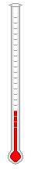
212°F Water 100°C
Boils

Water 0°C
32°F Freezes

Example: Convert 41°F to Celsius

C = (°F - 32°) x 5/9

C = (41 – 32) x 5/9

C = 9 x 5/9

C = 45/9

5°C = 41°F

Basic Math Handbook

Example: Convert 10°C to Fahrenheit

°F = (°C x 9/5) + 32°

°F = (10°C x 9/5) + 32°

°F = 90/5 = 32

°F = 18 + 32

°F = 50°

10°C = 50°F

There is another conversion method that is easier to remember. It consists of the same three steps regardless of whether you are converting from Celsius to Fahrenheit or vice versa.

Step One: Add 40°

Step Two: Multiply by 5/9 to convert to Celsius
or
Step Two: Multiply by 9/5 to convert to Fahrenheit

Step Three: Subtract 40°

Basic Math Handbook

Chapter Seven

Charts and Tables

Pipe Area and Volume

Inside Cross Sectional Volume in
Pipe Diameter Area (in2) Gallons Per Foot

1.5” 1.76 0.0908
2” 3.14 0.163
2.5” 4.90 0.254
3” 7.06 0.367
4” 12.96 0.672
6” 28.27 1.47
8” 50.26 2.61
10” 78.54 4.08
12” 113.10 5.86
16” 201.06 10.45
18” 254.47 13.20
20” 314.16 16.35
24” 452.39 23.42

Example:

A section of a ten inch water main is 1,450 feet long. What is the volume of water in that section of pipe?

Referring to the table above, we see that a 10” diameter pipe has a volume of 4.08 gallons per linear foot of pipe.

  - gallons/foot X 1,450 Feet = 5,916 gallons
Basic Math Handbook

Circular Tank Volumes Vertical Tanks

Diameter Gallons per in feet foot of depth

Example:
50 14,679.50
49 14.098.19
48 13,528.63
47 12,970.81
46 12,424.73
45 11,890.39
44 11,367.80
43 10,856.96
42 10,357.86
41 9,870.50
40 9,394.88
39 8,931.01
38 8,478.87
37 8,038.49
36 7,609.85
35 7,192.96
34 6,787.80
33 6,394.39
32 6,012.72
31 5,642.80
30 5,642.80
29 4,938.18
28 4,693.49
27 4,280.54
26 3,969.34
25 3,669.88
24 3,382.16
23 3,106.18
22 2,841.95
21 2,589.46
20 2,348.72
19 2,119.72
18 1,902.46
17 1,696.95
16 1,503.18
15 1,321.15
14 1,268.31
13 992.33
12 845.54
11 777.00
10 587.18
09 475.62
08 375.80
07 287.72
06 211.38
05 146.80
04 93.95
03 52.85
02 23.49
01 5.57

36 ft Diameter

A storage tank with
A diameter of 36 feet has 24
feet of water in it. What is
the volume of water in gallons?

Referring to the table
above, we see that a 36 ft diameter
cylinder has 7,609.85 gallons per
foot of depth.

24 ft X 7,609.85 gals/ft = 182,636.4
gallons

Basic Math Handbook

Horizontal Tanks

100%
90%
80%
70%
60%
50%
40%
30%
20%
10%

Percentage of Water Depth Percentage of Total Volume
To Total Depth

10% 5.22%
20% 14.22%
30% 26.2%
40% 37.4%
50% 50%
60% 62.6%
70% 73.8%
80% 85.8%
90% 94.8%
100% 100%

Example:
A horizontal tank 10 feet in diameter is measured to have 7 feet of water in the tank. The tank is 12 feet long. How much water is in the tank?

1. Referring to the table above for horizontal tanks we see that we need to determine the percentage of water depth to total depth. 7 feet water in tank
10 foot diameter tank = 70% full

2. Referring to the table we see that a horizontal tank with the water depth at 70 percent of the tank diameter will contain 73.8% of the total volume of the tank.

3. Referring to the table on the previous page we see that a tank with a diameter of 10 feet holds 587.18 gallons/ft.

Total tank volume = 587.18 gals/ft X 12 ft = 7,046.16 gal
Water volume = 7,046.16 gals X 73.8% = 5200 gallons

Basic Math Handbook

Pressure Conversion

Feet = PSI = PSI
Feet

2.31 1 0.4335
4.62 2 0.8670
6.93 3 1.3005
9.24 4 1.7340
11.54 5 2.16
13.85 6 2.60
16.16 7 3.03
18.47 8 3.46
20.78 9 3.90
23.09 10 4.33
46.18 20 8.67
69.27 30 13.00
92.36 40 17.34
115.45 50 21.67

Temperature Conversion

Fahrenheit = Centigrade = Centigrade
Fahrenheit

32 0 -17.78
41 5 -15
50 10 -12.22
57.2 14 -10
68 20 -6.67
86 30 -1.11
95 35 1.67
105.8 41 5
122 50 10
138.2 59 15
154.4 68 20
170.6 77 25
186.6 86 30
203 95 35
212 100 37.78

Basic Math Handbook

Flow Conversion

GPD = gallons per day; GPM = gallons per minute

GPD = GPM
GPM = ft³/sec

1,440 1 0.002228
2,880 2 0.004456
4,320 3 0.006684
5,760 4 0.008912
7,200 5 0.011140
8,640 6 0.013368
10,080 7 0.015596
11,520 8 0.017824
12,860 9 0.020052
14,400 10 0.022280
28,800 20 0.044560
43,200 30 0.066840
57,600 40 0.089120
72,000 50 0.111400
86,400 60 0.133680
100,800 70 0.155906
115,200 80 0.178240
128,600 90 0.200520
144,000 100 0.22280
288,000 200 0.44560
432,000 300 0.66840
576,000 400 0.89120
720,000 500 1.11400
864,000 600 1.33680
1,008,000 700 1.55906
1,152,000 800 1.78240
1,286,000 900 2.00520
1,440,000 1,000 2.2280

Basic Math Handbook

Volume Conversion

Gallons = ft³

Gallons = ft³

^{7.48} ¹ ^{0.134}
^{14.96} ² ^{0.268}
^{22.44} ³ ^{0.402}
^{29.22} ⁴ ^{0.436}
^{37.40} ⁵ ^{0.670}
^{44.88} ⁶ ^{0.804}
^{52.36} ⁷ ^{0.938}
^{59.84} ⁸ ^{1.072}
^{67.32} ⁹ ^{1.206}
^{74.8} ¹⁰ ^{1.34}
^{149.6} ²⁰ ^{2.68}
^{224.4} ³⁰ ^{4 .02}
^{292.2} ⁴⁰ ^{4.36}
^{374.0} ⁵⁰ ^{6.70}
^{448.8} ⁶⁰ ^{8.04}
^{523.6} ⁷⁰ ^{9.38}
^{598.4} ⁸⁰ ^{10.72}
^{673.2} ⁹⁰ ^{12.06}
748 100 ^{13.4}
1,496 200 26.8
2,244 300 40.2

2,922 400 43.6

3,740 500 67.0

4,4878 600 80.4

5,236 700 93.8

5,984 800 107.2

6,732 900 120.6

7,480 1,000 134.0

